Project Name
Student Name
Student ID
Supervisor: **name**

Final Year Report
COMP1682 Final Year Project

Program Title: BSc Hons Computing

Submission date: dd-mm-yyyy
Word count: xxx

Abstract
An abstract is a summary of your project: for Endeavor abstracts, from 200 to 350 words. It is used typically for academic presentations to give the reader a synopsis of the research project, and it can also be used to summarize a creativity project.
Sample’s abstract:
Project Name: Using GIS Site Suitability Analysis to Study Adaptability and Evolution of Life: Locating Springs in Mantle Units of Ophiolites
GIS is a powerful tool that can be used to locate springs sourced in ophiolites. The unique features associated with these springs include a reducing subsurface environment reacting at low temperatures producing high pH, Ca-rich formation fluids with high dissolved hydrogen and methane. Because of their unique chemical characteristics, these areas are often associated with microbes and are thought to be similar to the features that enabled life to evolve on Earth. Locating and sampling these springs could offer a deeper look into Earth's deep biosphere and the history of life on Earth. Springs have traditionally been located using expensive and time-consuming field techniques. Field work can be dangerous. The goal of this study was to develop a model that could locate these unique geological features without first going into the field, thus saving time, money and reducing the risks associated with remote field localities. A GIS site suitability analysis works by overlaying existing geo-referenced data into a computer program and adding the different data sets after assigning a numerical value to the important fields. For this project, I used surface and ground water maps, geologic maps, a soil map, and a fault map for four counties in Northern California. The model has demonstrated that it is possible to use this time of model and apply it to a complex geologic area to produce a usable field map for future field work.
Note: cái này là tham khảo, không sử dụng lại vì sẽ dính đạo văn

Acknowledgements
I would like to express my deepest appreciation to all those who provided me the possibility to complete this report. A special gratitude I give to our final year project manager, [Ms/Mr/Dr Surname], whose contribution in stimulating suggestions and encouragement, helped me to coordinate my project especially in writing this report.
Furthermore, I would also like to acknowledge with much appreciation the crucial role of the staff of [Ms/Mr/Dr Surname], who gave the permission to use all required equipment and the necessary materials to complete the task “SPECIFY NAME”. A special thanks goes to my team mate, [Ms/Mr/Dr Surname], who help me to assemble the parts and gave suggestion about the task “SPECIFY NAME”. Last but not least, many thanks go to the head of the project, [Ms/Mr/Dr Surname] whose have invested his full effort in guiding the team in achieving the goal. I have to appreciate the guidance given by other supervisor as well as the panels especially in our project presentation that has improved our presentation skills thanks to their comment and advices.
Note: cái này là tham khảo, không sử dụng lại vì sẽ dính đạo văn

Table of Contents
1. Introduction 8
1.1 General Overview 8
1.2 Problem Statement 8
1.3 Project Aim 8
1.4 Specific Objectives 8
1.5 Scope and Limitations 8
1.6 Report Structure 8
2. Background and Literature Review 9
2.1 Introduction 9
2.2 Problem Domain Analysis 9
2.3 Critical Review of Existing Solutions 10
2.4 Critical Review of Enabling Technologies & Methodologies 10
2.5 Summary and Identification of the Research Gap 11
3. Requirements Analysis 11
3.1 Research Methodology 11
3.2 Market Analysis and User Needs 12
3.3 Functional Requirements with MoSCoW prioritisation 12
3.4 Non-functional Requirements 13
4. Methodology and Project Planning 13
4.1 Development Methodology 13
4.2 Project Plan & Timeline 13
4.3 Feasibility Analysis 14
4.4 Evaluation Plan & Success Metrics 14
5. System Design and Architecture 15
5.1 Rich Picture 15
5.2 System Architecture 15
5.3 Technology Stack 16
5.4 Detailed Design Diagrams 17
5.5 API Design 17
6. Implementation 18
6.1 Development Environment 18
6.2 Backend & Frontend Implementation 18
6.3 Database Implementation 19
6.4 Deployoment 19
6.5 Project Management 19
7. Testing 19
7.1 Testing Strategy 19
7.2 Test Cases and Results 19
8. Legal, Social, Ethical, and Professional Issues 20
9. Conclusion and Critical Reflection 21
9.1 Summary of Achievements 21
9.2 Critical Project Evaluation 21
9.3 Personal Reflection and Key Learnings 22
9.4 Recommendations for Future Development 23
9.5 Final Conclusion 23
10. References 24
11. Appendix A – Project Proposal 25
12. Appendix B – Images of final product 26

Introduction
This section sets the stage for your entire project. It should be concise, engaging, and clearly articulate the project's purpose.

General Overview
Briefly introduce the project's domain (e.g., FinTech, mobile health, e-commerce) and its relevance.

Problem Statement
This is the core of your introduction. Clearly and precisely state the problem, gap, or challenge your project addresses. Why does this problem need solving?

Project Aim
State the single, overarching aim of your project in one sentence. What is the primary solution you are building?

Specific Objectives
List 3-5 specific, measurable, achievable, relevant, and time-bound (SMART) objectives. These are the concrete steps you will take to achieve your aim. For example:
- Objective 1: To design and develop a responsive web application for user authentication and profile management.
- Objective 2: To implement a RESTful API for handling data transactions between the client and server.

Scope and Limitations
Clearly define the boundaries of your project. What features are included (scope)? What is explicitly not included (limitations)? Be realistic about what you can achieve.

Report Structure
Briefly outline the structure of the rest of the report.

Background and Literature Review

Introduction
Start by setting the scene for this chapter.
- Purpose Statement: Begin with a clear statement of intent. e.g., "This chapter critically reviews existing literature and competing solutions to establish the context and justify the need for the proposed project."
- Scope of Research: Define the boundaries of your review. What are you including and excluding? e.g., "The review focuses on mobile-based fitness applications released in the last five years, with a specific emphasis on solutions utilizing gamification. It will also examine the underlying technologies, specifically cross-platform frameworks like React Native and Flutter."
- Research Strategy: Briefly mention how you found your sources to add credibility. e.g., "Sources were gathered from academic databases such as the ACM Digital Library and IEEE Xplore, as well as industry-leading app stores (Google Play, Apple App Store) and market analysis reports."

Problem Domain Analysis
This is the "big picture" context. You need to demonstrate that you understand the world your project lives in.
Historical Context and Current Trends: Discuss the evolution of this domain. What are the key technological or social trends driving its importance? e.g., For a remote work tool, discuss the post-2020 shift to distributed teams and the resulting challenges in collaboration.
Key Concepts and Terminology: Define any core theories, models, or technical terms that are central to your project. Don't assume the reader knows everything. e.g., If building a recommendation system, explain concepts like 'Collaborative Filtering' or 'Content-Based Filtering'.
Significance and Impact: Use statistics and credible sources to show why this problem matters. Who is affected? What are the consequences of not solving it? e.g., "According to a 2024 study by MarketWatch, food waste accounts for an estimated $1 trillion in economic losses globally..."

Critical Review of Existing Solutions
This is where you analyze the competition. The goal is to identify their weaknesses to create a space for your project.
- Identify Competitors: Select 2-4 primary competitors or analogous systems (these can be commercial products or academic research projects).
- Create a Comparison Matrix: A table is the most effective way to present this analysis. This forces you to be systematic.
Feature / Aspect | Solution A (e.g., MyFitnessPal) | Solution B (e.g., Strava) | Solution C (Academic Paper X) | Your Proposed Project
Target Audience | General fitness/diet | Athletes, cyclists, runners | Theoretical model | (Your target audience)
Core Technology | Native iOS/Android | Native iOS/Android | Python Simulation | (e.g., Flutter, React)
Key Feature 1 | Calorie Tracking | GPS Route Tracking | N/A | Yes
Key Feature 2 | Recipe Database | Social Feed & Leaderboards | N/A | Yes
Strengths | Huge food database | Strong community features | Novel algorithm | (Your unique selling points)
Weaknesses | Outdated UI, poor social integration | Limited nutrition tracking | Not a real-world product | (How you overcome weaknesses)
Written Analysis: After the table, write a narrative that interprets the findings. Don't just repeat the table's contents. Synthesize it. e.g., "As the comparison matrix illustrates, a significant gap exists in the market. While Solution A offers comprehensive nutritional data, it lacks the community engagement that makes Solution B successful. Solution B, conversely, overlooks the dietary aspect, which our market research indicates is a key user demand."

Critical Review of Enabling Technologies & Methodologies
Here you justify your technical and process choices with evidence. This proves your decisions are not arbitrary.
Frontend Frameworks: Compare at least two options (e.g., React vs. Vue). Discuss criteria like performance, ecosystem, learning curve, and suitability for your specific project. e.g., "While Vue.js offers a lower barrier to entry, React was chosen due to its vast library ecosystem, including robust state management tools like Redux, which is essential for handling the complex application state required by our project."
Backend Technologies: Compare options like Node.js (with Express), Python (with Django/Flask), etc. Justify your choice based on factors like speed of development, performance, and database compatibility.
Database Systems: Compare SQL (e.g., PostgreSQL) vs. NoSQL (e.g., MongoDB). Explain why your project's data structure is better suited for one over the other. e.g., "Given the highly structured and relational nature of our data (users, orders, products), a SQL database like PostgreSQL was selected to ensure data integrity through ACID compliance."
Development Methodologies: Compare Agile vs. Waterfall in the context of your project. Explain why an iterative approach like Agile/Scrum is almost always preferred for projects with evolving requirements.

Summary and Identification of the Research Gap
This is the conclusion of your argument. It's the most critical part of the chapter.
- Synthesize Your Findings: Briefly bring together the main points from your review of solutions, technology, and market analysis.
- State the Gap Explicitly: This should be a clear and confident statement. e.g., "In summary, the literature review have identified a clear gap: there is no single solution on the market that combines [Key Feature X from a competitor] with [User Need Y from your survey] in a technologically modern and user-friendly package. Existing tools are either too complex, too niche, or technically outdated."
- Position Your Project: Conclude by stating exactly how your project will fill that gap. e.g., "Therefore, this project aims to address this gap by developing a cross-platform mobile application using Flutter, which will provide [Unique Value Proposition 1] and [Unique Value Proposition 2], directly addressing the frustrations and goals of our target user persona."

Requirements Analysis

Research Methodology
Research Method: Go into detail. If you ran a survey, what tool did you use (e.g., Google Forms)? How many responses did you get? What were the key demographics? If you did interviews, how did you select participants?

Market Analysis and User Needs
Analysis of Results: Present your key findings with visuals (charts, graphs). More importantly, interpret the data. What does it mean? e.g., "The survey revealed that 78% of respondents were 'frustrated' or 'very frustrated' with existing solutions' user interfaces. This quantitative data strongly supports our project's focus on a streamlined and modern UX/UI design."
- Detailed User Personas: Build on the basic persona. Give it life.
  - Image: A stock photo helps make the persona feel real.
  - Bio: A short paragraph about their life and background.
  - Goals: What are they trying to achieve in relation to your project? (e.g., "Wants to track daily expenses without spending more than 5 minutes a day.")
  - Frustrations: What are their pain points with current solutions? (e.g., "Hates complicated signup processes and apps cluttered with ads.")
  - Motivations: What drives them? (e.g., "Is motivated by seeing clear progress towards a savings goal.")

Functional Requirements with MoSCoW prioritisation
List user stories with MoSCoW prioritization.

ID | Description | Priority  (Must – Should – Could -Won’t) | Estimation  (2 – 3 – 5- 8 days)
USR_01 | As an <user>, I want <something>¸ so that <why> | Must | 8 days
USR_02 | As an <user>, I want <something>¸ so that <why> | Should | 2 days
ADM_01 | As an <user>, I want <something>¸ so that <why> | Could | 2 days

SUMMARY
Priority | Number of features | Number of days
Must | 1 | 8
Should | 1 | 2
Could | 1 | 2
TOTAL | 3 | 14

Non-functional Requirements
Detail requirements like performance, security, usability, etc.
ID | Description
NF_01 | Description
NF_02 | Description
NF_03 | Description

Methodology and Project Planning
This chapter explains the "how." How will you build and manage the project? How will you know if it's a success?

Development Methodology
State your chosen methodology (e.g., Agile Scrum) and describe how you practically applied it.

Project Plan & Timeline
Include a visual timeline, such as a Gantt chart, showing the project's phases (e.g., Discovery, Design, Development Sprints, Testing, Deployment) and key milestones. This demonstrates your ability to plan and manage your time effectively.
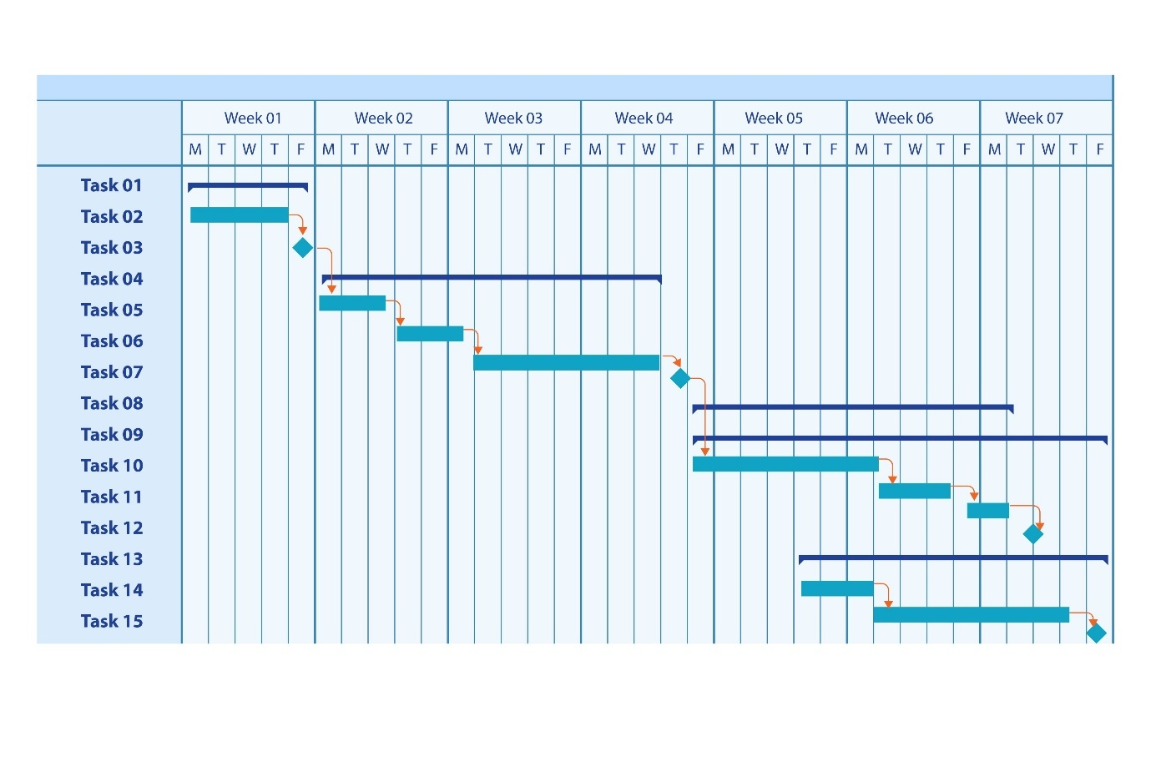

Feasibility Analysis
Briefly assess the project's viability:
- Technical: Do you have the necessary skills and access to the required tools?
- Economic: Are the costs (e.g., hosting, APIs) manageable within the project's scope?
- Operational: Will the proposed solution be usable and maintainable?

Evaluation Plan & Success Metrics
Define your success criteria before you start building.
List specific and measurable metrics.
- Quantitative Example: "Achieve an 80% task completion rate during User Acceptance Testing."
- Qualitative Example: "Receive an average user satisfaction rating of 4 out of 5 from test users on a post-test survey."

System Design and Architecture
Here, you provide the blueprint for your system. Use diagrams extensively. A picture is worth a thousand words.

Rich Picture
Include the rich picture and briefly describe your product here
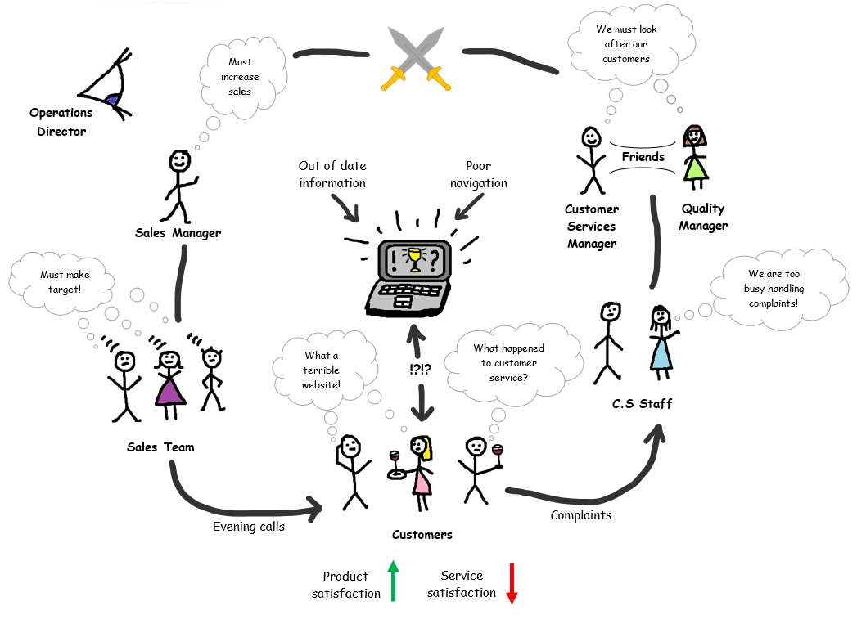

System Architecture
Provide a high-level overview of your architecture (e.g., Client-Server, Microservices).
Use the C4 model as a guide: include a System Context Diagram (showing how your system fits into the world) and a Container Diagram (showing the major building blocks like web app, mobile app, database, API).
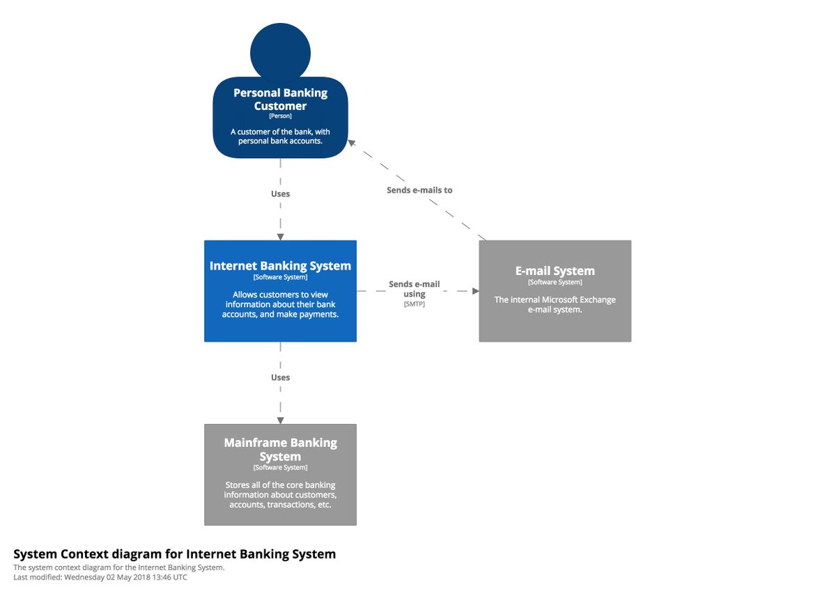
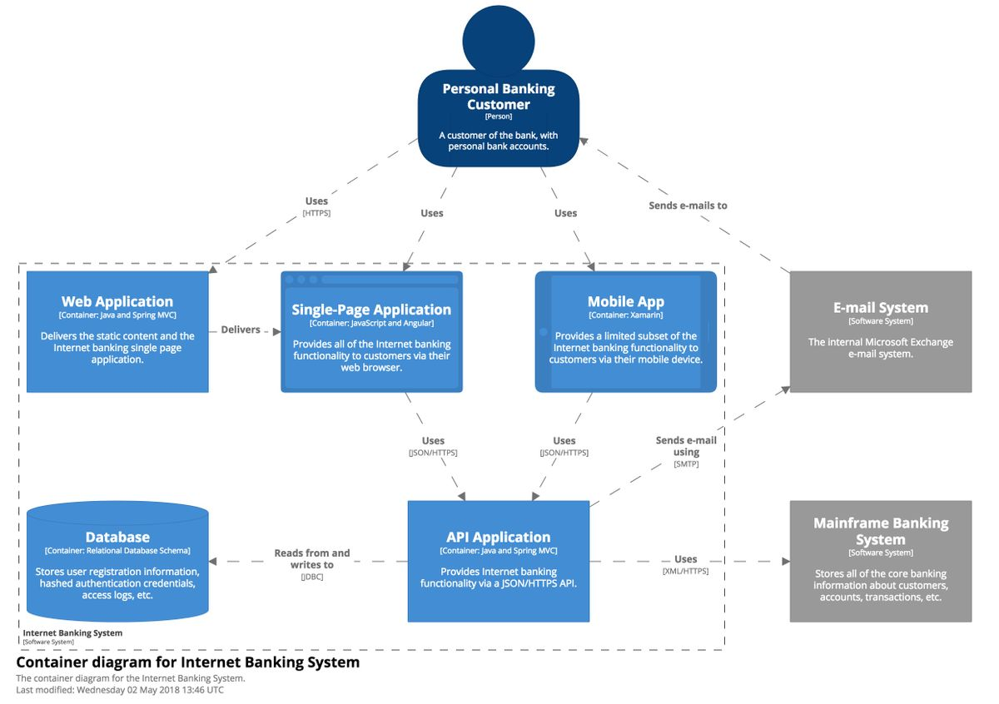

Technology Stack
Present your full tech stack in a clear table format. For each item, list the technology, version, and a brief justification for its selection for your project with references.
Example:
Category | Technology | Justification | References
Frontend | React | For building a fast, component-based user interface.
Backend | Node.js & Express.js | For a consistent JavaScript environment and building efficient RESTful APIs.
Database | MongoDB Atlas | For its flexible NoSQL data model, ideal for agile development.
Authentication | JSON Web Token (JWT) | For implementing secure, stateless user authentication.
Version Control | Git & GitHub | The industry standard for source code management and collaboration.
Deployment | Vercel (Frontend) & Heroku (Backend) | For simplified, continuous deployment and easy scalability.
API Testing | Postman | Essential tool for testing and validating backend API endpoints.

Detailed Design Diagrams
Entity Relationship Diagram (ERD): The blueprint for your database.
UML Diagrams: Include the most relevant ones for your project.
A Use Case Diagram is excellent for showing user interactions, while Activity Diagrams are great for modeling complex workflows.

API Design
If you have a backend API, document key endpoints. Use a table showing the URL, HTTP Method (GET, POST, etc.), a brief description, and sample request/response bodies.
Id | URL | Method | Description | Params | Returns
1 | /reservation | POST | Users reserve parking slot | user_id, garage_id, slot_id | reservation_id

Implementation

Development Environment
List the tools you used: IDE (e.g., VS Code), version control (Git/GitHub), project management software (Jira/Trello), and any key libraries.

Backend & Frontend Implementation
Include screenshots of your project's folder structure and briefly explain the organizational logic (e.g., "The backend follows a layered architecture with separate folders for controllers, services, and repositories...").
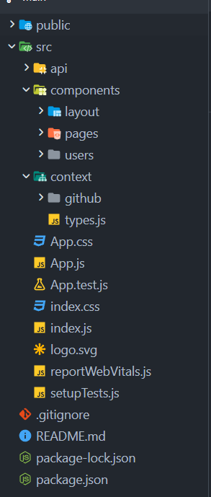  Front End |   Back End

Provide meaningful code samples. Choose a complex function or a core component. Use code blocks and add comments to explain what the code does.

Database Implementation
Briefly explain how you created the physical database from your ERD. Mention the database management system (e.g., MySQL, PostgreSQL, MongoDB).

Deployoment
Describe the steps you took to deploy your application (e.g., "The application was containerized using Docker and deployed to Heroku..."). Include screenshots of the live, working application.

Project Management
Provide screenshots of your Trello board or GitHub Projects page to show how you managed tasks. A screenshot of your commit history from GitHub is also excellent evidence of consistent work.

Testing
Demonstrate that your application is robust and reliable. A systematic approach to testing is a hallmark of professional development.

Testing Strategy
Describe the different types of testing you performed (e.g., Unit Testing for individual functions, Integration Testing to ensure components work together, and User Acceptance Testing with real users).

Test Cases and Results
Present a table with sample test cases. Include columns for Test ID, Test Description, Steps, Expected Result, Actual Result, and Pass/Fail.
Test ID | Test Description | Steps | Expected Result | Actual Result | Pass/Fail
LOGIN-01 | Successful Login | 1. Enter valid username "admin".  2. Enter valid password "pass123".  3. Click "Login". | User is redirected to the dashboard page. A "Welcome, admin!" message is shown. | User was redirected to the dashboard. The welcome message was displayed. | Pass
LOGIN-02 | Failed Login (Wrong Password) | 1. Enter valid username "admin".  2. Enter invalid password "wrongpass".  3. Click "Login". | An error message "Invalid username or password" appears. User stays on the login page. | The specified error message appeared. The user was not redirected. | Pass
LOGIN-03 | Failed Login (Empty Username) | 1. Leave username field empty.  2. Enter a password.  3. Click "Login". | An error message "Username is required" appears. User stays on the login page. | The specified error message appeared. The user was not redirected. | Pass

Legal, Social, Ethical, and Professional Issues
Show that you are a responsible developer who considers the broader impact of their work.
What to include:
Legal: Discuss data privacy laws (like GDPR) and how your project complies. Mention software licenses for any third-party libraries you used.
Ethical: How do you handle user data ethically? Do you ask for consent? Is the data stored securely?
Social: What is the potential social impact of your project? Does it help or harm any group of people?
Professional: Mention professional standards you followed, such as writing clean code, using version control, and conducting thorough testing.

Conclusion and Critical Reflection
This final chapter synthesizes everything you've done. It answers the questions: "Did you achieve what you set out to do?", "What did you learn?", and "What's next?".

Summary of Achievements
Begin by providing a concise summary of the project's outcome. This section directly connects back to the goals you set in your introduction.
- Restate Project Aim: Briefly remind the reader of the project's main goal.
- Evaluate Against Objectives: This is the most important part. Create a table or a clear list that explicitly addresses each of the specific objectives you defined in Chapter 1. Provide evidence for each.
Objective (from Chapter 1) | Met? (Yes/No/Partially) | Evidence / Outcome
1. To design and develop a user authentication system. | Yes | A fully functional login and registration system was implemented using JWT for security. Users can create accounts and log in successfully.
2. To implement a RESTful API for data transactions. | Yes | Over 20 API endpoints were created and documented with Swagger, handling all core application data as planned.
3. To build a responsive frontend for profile management. | Partially | The profile management dashboard is functional on desktop browsers but requires further optimization for mobile screens.

Critical Project Evaluation
This is where you demonstrate critical thinking by analyzing the project's process and results honestly.
Successes and Strengths (What Went Well):
- Discuss the most successful aspects of the project.
- Was a particular technology choice highly effective? e.g., "Choosing Flutter for the mobile app proved to be an excellent decision, as it significantly accelerated development time."
- Did a specific design pattern or architectural decision work out well? e.g., "The use of a microservices architecture for the backend allowed for clear separation of concerns and easier debugging."
Challenges and Weaknesses (What Didn't Go Well):
- Be honest about the difficulties you faced. This demonstrates maturity and problem-solving skills.
- Did you underestimate the complexity of a feature? e.g., "Implementing the real-time chat feature was far more complex than anticipated, leading to a two-week delay in the project schedule."
- Did a chosen library have limitations you didn't foresee? e.g., "The initial charting library lacked the necessary customization options, forcing a late-stage migration to a more robust alternative."
- Discuss how you tackled these challenges.

Personal Reflection and Key Learnings
Focus on your own growth throughout the project.
- What You Learned: Be specific. Don't just say "I learned Python." Instead, say "I developed a deep understanding of asynchronous programming in Python using FastAPI to build high-performance APIs."
- Skills Developed: Think beyond just technical skills. What about project management, time management, or problem-solving? e.g., "Managing the project via a Kanban board in Trello greatly improved my ability to prioritize tasks and track progress against deadlines."
- What You Would Do Differently: If you could start over, what would you change about your approach? e.g., "I would have spent more time on database design initially to avoid the need for schema migrations later in the project."

Recommendations for Future Development
Show that you are thinking about the project's long-term potential. Present a clear roadmap for what could come next.
- Feature Enhancements: Suggest 2-3 specific new features that would add significant value. e.g., "Introduce a user role and permissions system to allow for administrative access."
- Technical Improvements: Suggest ways to improve the project from a technical standpoint. e.g., "Refactor the backend to implement a caching layer with Redis to improve response times for frequently accessed data." or "Add comprehensive unit and integration test suites to improve code reliability."
- Scalability: How could the application be prepared to handle more users or data? e.g., "Migrate the deployment from a single server to a cloud-based, auto-scaling container service like AWS ECS or Kubernetes."

Final Conclusion
This is a short, powerful paragraph that closes the entire report.
- Reiterate the core problem statement from your introduction.
- Summarize your solution and its key contribution or innovation.
- End with a final, forward-looking statement that encapsulates the project's value and potential impact. e.g., "In conclusion, this project successfully addressed the gap in the market for an intuitive student-focused planning tool. By integrating task management and scheduling into a single platform, the developed prototype provides a robust foundation for a product that could significantly enhance student productivity and organization."

References
Your list of all the academic papers, articles, and other resources you cited in your report. Ensure this is formatted perfectly in the required Harvard style.
References rất quan trọng, chiếm 20% số điểm

Appendix A – Project Proposal
Include your Project Proposal here for references

Appendix B – Images of final product
Include your images for your final product here for references

